**Title:**

Use of amazon EC2 service (IAAS) to host an instance and later use that instance as a web server/data server.

**Abstract:**

The project required account creation on Amazon EC2. Then we created an Amazon EC2 Ubuntu 16.04 instance. After creating an Amazon EC2 instance , we need to SSH into the instance using Cygwin. Then we setup a LAMP server on the instance with Apache, PHP, PHPMyadmin.After that we created www group and add our Amazon EC2 instance user to that group. Then we transferred files using filezilla from our PC to instance and hosted a website on the instance.

**Introduction:**

**Amazon Web Services (AWS)**, is a collection of [cloud computing](https://en.wikipedia.org/wiki/Cloud_computing) services that make up the on-demand computing platform offered by [Amazon.com](https://en.wikipedia.org/wiki/Amazon.com). These services operate from 12 geographical regions across the world. The most central and best-known of these services arguably include [Amazon Elastic Compute Cloud](https://en.wikipedia.org/wiki/Amazon_Elastic_Compute_Cloud), also known as "EC2", and [Amazon Simple Storage Service](https://en.wikipedia.org/wiki/Amazon_Simple_Storage_Service), also known as "S3". AWS now has more than 70 services that range from compute, storage, networking, database, analytics, application services, deployment, management and mobile. Amazon markets AWS as a service to provide large computing capacity quicker and cheaper than a client company building an actual physical [server farm](https://en.wikipedia.org/wiki/Server_farm).

**Amazon EC2**:

Amazon Elastic Compute Cloud (Amazon EC2) is a web service that provides resizable compute capacity in the cloud. It is designed to make web-scale [cloud computing](https://aws.amazon.com/what-is-cloud-computing/) easier for developers.

Amazon EC2’s simple web service interface allows you to obtain and configure capacity with minimal friction. It provides you with complete control of your computing resources and lets you run on Amazon’s proven computing environment. Amazon EC2 reduces the time required to obtain and boot new server instances to minutes, allowing you to quickly scale capacity, both up and down, as your computing requirements change. Amazon EC2 changes the economics of computing by allowing you to pay only for capacity that you actually use. Amazon EC2 provides developers the tools to build failure resilient applications and isolate themselves from common failure scenarios.

## **Benefits**

## **Elastic Web-Scale Computing**

Amazon EC2 enables you to increase or decrease capacity within minutes, not hours or days. You can commission one, hundreds or even thousands of server instances simultaneously. Of course, because this is all controlled with web service APIs, your application can automatically scale itself up and down depending on its needs.

### **Completely Controlled**

You have complete control of your instances. You have root access to each one, and you can interact with them as you would any machine. You can stop your instance while retaining the data on your boot partition and then subsequently restart the same instance using web service APIs. Instances can be rebooted remotely using web service APIs. You also have access to console output of your instances.

### **Flexible Cloud Hosting Services**

You have the choice of multiple instance types, operating systems, and software packages. Amazon EC2 allows you to select a configuration of memory, CPU, instance storage, and the boot partition size that is optimal for your choice of operating system and application. For example, your choice of operating systems includes numerous Linux distributions, and [Microsoft Windows Server](https://aws.amazon.com/windows/).

### **Designed for use with other Amazon Web Services**

Amazon EC2 works in conjunction with Amazon Simple Storage Service (Amazon S3), Amazon Relational Database Service (Amazon RDS), Amazon SimpleDB and Amazon Simple Queue Service (Amazon SQS) to provide a complete solution for computing, query processing and storage across a wide range of applications.

### **Reliable**

Amazon EC2 offers a highly reliable environment where replacement instances can be rapidly and predictably commissioned. The service runs within Amazon’s proven network infrastructure and data centers. The Amazon EC2 Service Level Agreement commitment is 99.95% availability for each Amazon EC2 Region.

### **Secure**

Amazon EC2 works in conjunction with [Amazon VPC](https://aws.amazon.com/vpc/) to provide security and robust networking functionality for your compute resources.

**Steps in Implementation:**

1 Click launch or with the EC2 console

**Cygwin**is a [Unix-like](https://en.wikipedia.org/wiki/Unix-like) environment and [command-line interface](https://en.wikipedia.org/wiki/Command-line_interface) for [Microsoft Windows](https://en.wikipedia.org/wiki/Microsoft_Windows). Cygwin provides native integration of Windows-based applications, data, and other system resources with applications, software tools, and data of the Unix-like environment.

**FileZilla** is a [free software](https://en.wikipedia.org/wiki/Free_software), [cross-platform](https://en.wikipedia.org/wiki/Cross-platform) [FTP](https://en.wikipedia.org/wiki/FTP) application, consisting of FileZilla Client and FileZilla Server.The client supports [FTP](https://en.wikipedia.org/wiki/File_Transfer_Protocol), [SFTP](https://en.wikipedia.org/wiki/SSH_file_transfer_protocol) and [FTPS](https://en.wikipedia.org/wiki/FTPS) (FTP over [SSL/TLS](https://en.wikipedia.org/wiki/Transport_Layer_Security)). Support for [SFTP](https://en.wikipedia.org/wiki/SSH_file_transfer_protocol) ([SSH](https://en.wikipedia.org/wiki/Secure_Shell) File Transfer Protocol), which can be used to share folders over a network, is not implemented in FileZilla Server.

**Other familiar tools used:**

Apache2 sever on Ubuntu

Pypmyadmin

Php5 on ubuntu

MySQL

**Steps followed for configuration:**

1. Create an Amazon Web Services account.
2. Create a new instance on EC2 with a private key.

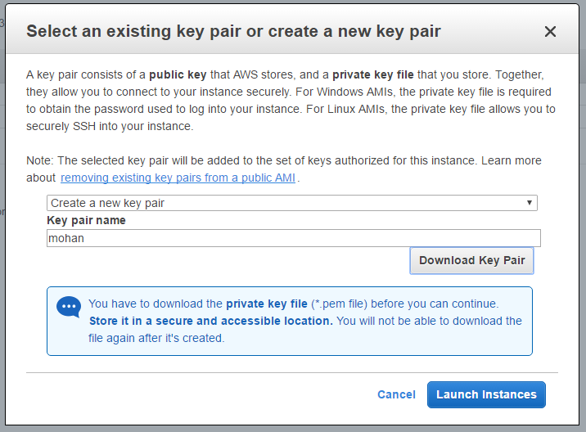

1. Launch the instance.

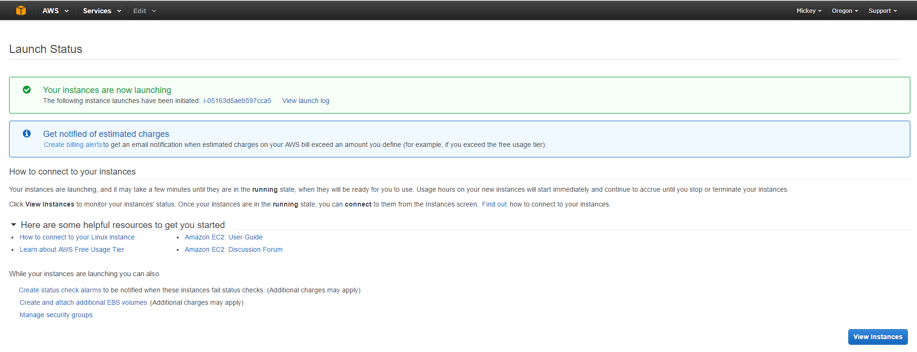

1. View or change instance if needed.

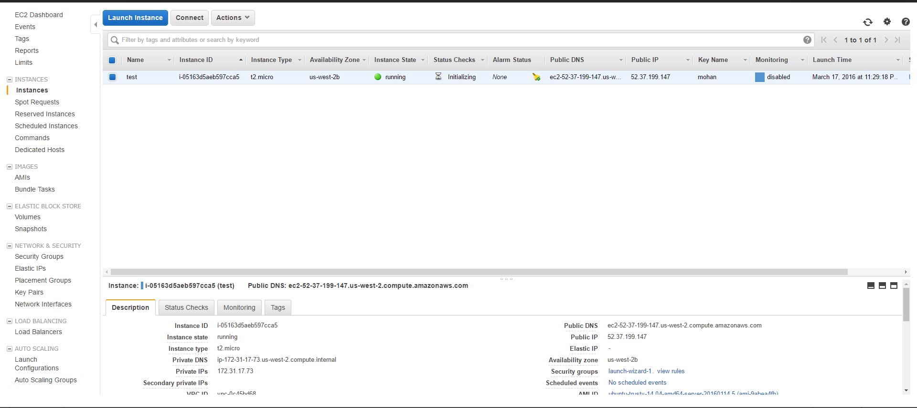

1. Use Cygwin with key to login via ssh to remote machine.

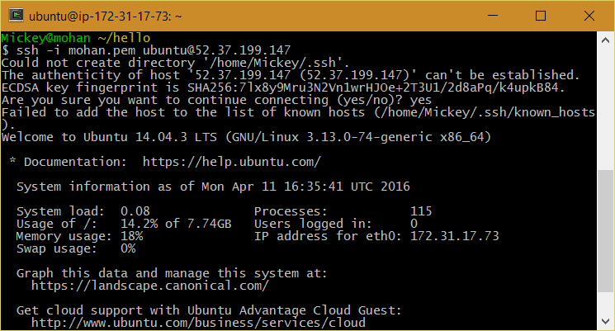

1. Configure a web server on that machine. (Apache2/phpmyadmin/phpmysql).

<https://www.howtoforge.com/perfect-server-ubuntu-14.04-apache2-php-mysql-pureftpd-bind-dovecot-ispconfig-3>

1. Use filezilla to transfer files to the server binded with the Public key.

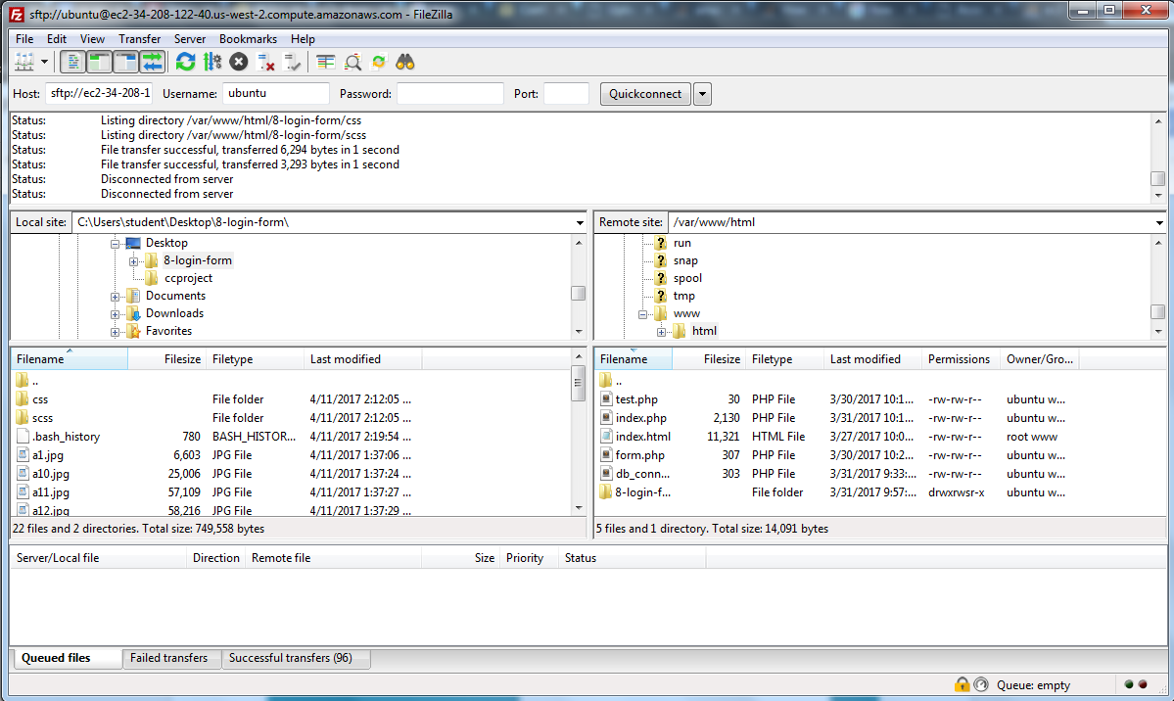

1. Use phpmyadmin from browser for setting up databases.



1. Enter ip-address on the browser to see your website.

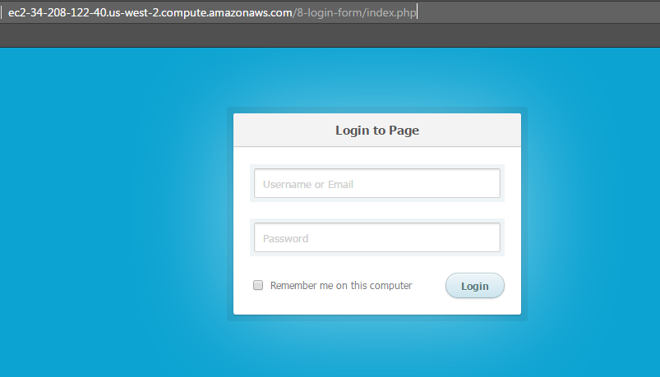

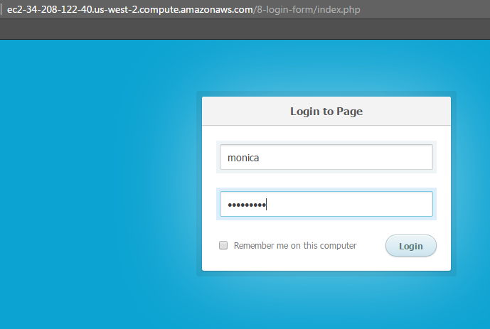



**Conclusion:**

Hence we have successfully studied and implemented amazon EC2 service (IAAS) to host an instance and later use that instance as a web server/data server.

**References:**

<https://www.howtoforge.com/perfect-server-ubuntu-14.04-apache2-php-mysql-pureftpd-bind-dovecot-ispconfig-3> : For configuration of apache